**CeA CRF Ephys Paper  
STATISTICS REFERENCE:**

**ALL GRAPHPAD PRISM RESULTS FOR EVERY FIGURE**

James M. Irving  
Sonia Aroni  
Houman Qadir  
Dennis Sparta

Updated: 09/03/18

GENERAL NOTES

09/03/18:

Updated this document with the latest version of the figure legends and figures from Sonia.

Added figure 2B’s statistics from old place in fig 4.

TABLE OF CONTENTS

I. FIGURE 1 1

JPG 1

LEGEND 1

STATISTICS 2

Firing Rate: 2

Coefficient of Variation: 2

Burst Rate 2

II. FIGURE 2 3

JPG 3

LEGEND 3

STATISTICS 4

Correlation of CRF Firing Rates [New 2B: was old Fig 4] 4

Firing Rate 5

% Spikes in Bursts 5

Burst Duration 5

Burst Rate 6

# of Spikes Per Burst 6

CV 6

Intraburst Freq 7

III. FIGURE 3 8

JPG 8

LEGEND 8

STATISTICS 9

Firing Rate Z-scores [New Licks]: 9

% of Spikes in Bursts: 10

RateSplits – Change in Rate Bar Graphs [CRF-P vs CRF-NR] 10

RateSplits – Normalized Firing Rate – CRF-P 10

RateSplits – Normalized Firing Rate – CRF-NR 11

RateSplits – CHANGE IN % SPIKES - CRF-P: (Δ-) vs (Δ+) 12

RateSplits – CHANGE IN % SPIKES - CRF-NR: (Δ-) vs (Δ+) 13

IV. FIGURE 4 14

JPG 14

LEGEND 14

STATISTICS 15

Fig 4A, Bar: CRF-P vs CRF-NR: Early vs Late - Firing Rate (Hz) 15

Fig 4A, Line: CRF-P vs CRF-NR: Early vs Late By Hour: Firing Rate (Hz) 15

Fig 4B, Bars: CRF-P vs CRF-NR: Early vs Late - % Spikes In Bursts 17

Fig 4B, Line: CRF-P vs CRF-NR: Early vs Late - % Spikes In Bursts 17

V. FIGURE S1 19

JPG 19

LEGEND 19

# FIGURE 1

## JPG

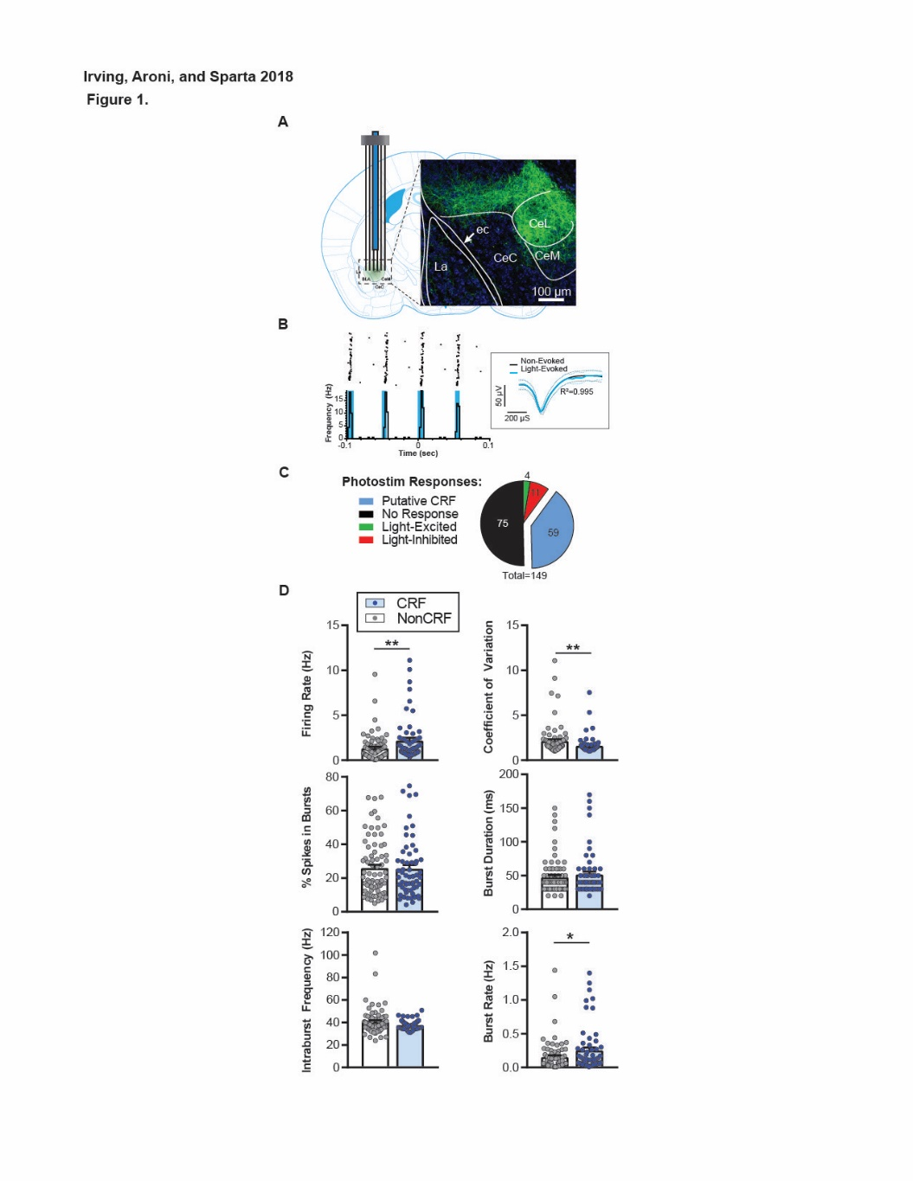

## LEGEND

Figure 1. Optical identification of CRF neurons *in vivo.* **A)** Scaled diagram of optical-fiber coupled microarray implanted into the central amygdala of CRF-cre mice, and local CeA injection of AAV-DIO –Channelrhodopsin2-EYFP virus, whose expression is showed in the image. **B)** Peristimulus time histogram and scatter plot showing identified CRF neurons. Units were classified as CRF only if they fired within 10 ms of the onset of a 4 ms-long light pulse, and the light-evoked waveforms had an R2 >0.9 compared to non-light evoked waveforms. **C)** The pie chart shows that out of 149 total units, 59 were identified as putative CRF neurons, 75 non-responsive to light, and a small population excited (4) or inhibited (11). Due to the low N for these light responses, we focused on CRF units vs non-light-responsive units, herein “NonCRF”. **D)** Electrophysiological characterization of CRF vs non-CRF neurons. Graphs showing firing rate, coefficient of variation, % of spikes in bursts, burst duration, intraburst frequency, and burst rate. Error bars are standard error of the mean. We found CRF units had a higher firing rate (U=1589, p=.005), a smaller coefficient of variation (U=1488, p=.0011), and a higher burst rate (U=1770, p=.0469) when compared to non-CRF units. **p<.01, *p<.05, Mann-Whitney test.

## STATISTICS

[Prism File](https://www.dropbox.com/s/t7vdf8z2gjv2rw1/Family%20of%20CRF%20vs%20NonCRF%20Properties%20for%20Stats.pzfx?dl=0)-

### Firing Rate:

#### Normal/parametric?

No, failed D’agostino & Pearson , shapiro willik tests

#### Stats Including Outliers

|  |  |
| --- | --- |
| Mann Whitney test |  |
| P value | 0.0050 |
| Exact or approximate P value? | Exact |
| P value summary | ** |
| Significantly different (P < 0.05)? | Yes |
| One- or two-tailed P value? | Two-tailed |
| Sum of ranks in column B,C | 4439 , 4606 |
| Mann-Whitney U | 1589 |

### Coefficient of Variation:

#### Normal/parametric?

A: No, failed both D’agostino and Shapiro-Willik

#### Stats Including Outliers

|  |  |
| --- | --- |
| Mann Whitney test |  |
| P value | 0.0011 |
| Exact or approximate P value? | Exact |
| P value summary | ** |
| Significantly different (P < 0.05)? | Yes |
| One- or two-tailed P value? | Two-tailed |
| Sum of ranks in column B,C | 5787 , 3258 |
| Mann-Whitney U | 1488 |

### Burst Rate

#### Normal/parametric?

A: No, failed both

#### Stats Including Outliers

|  |  |
| --- | --- |
| Mann Whitney test |  |
| P value | 0.0469 |
| Exact or approximate P value? | Exact |
| P value summary | * |
| Significantly different (P < 0.05)? | Yes |
| One- or two-tailed P value? | Two-tailed |
| Sum of ranks in column B,C | 4620 , 4425 |
| Mann-Whitney U | 1770 |

# FIGURE 2

## JPG

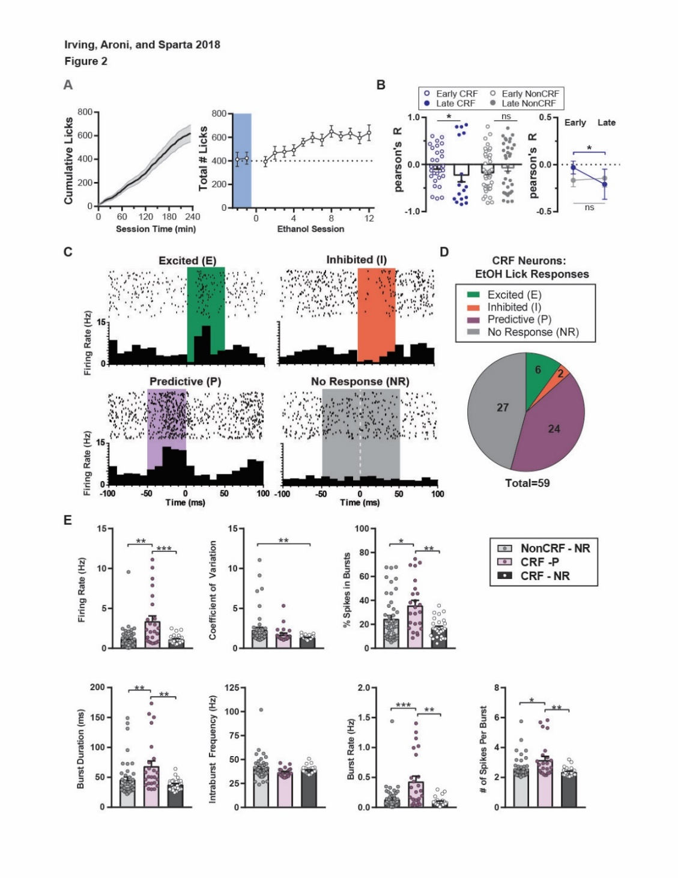

## LEGEND

Figure 2. CRF Neurons encode licking-behavior. **A, Left)** Average cumulative licks during a drinking session for all recorded sessions. **A, right)** Graph of representative number of licks over repeated ethanol sessions in a different cohort of mice. **B)** Graphs show that overall, CRF units had a significant shift in their correlation values for firing rate vs cumulative licks (D=0.4804, p=.0134) whereas non-CRF units did not (D=0.2267, p=.2951). *p<.05, Kolmogorov-Smirnov test. **C)** Perievent Raster plots for representative units for each lick-response type. Units were classified into 4 lick-response types, based upon changes in firing rates during 3 time periods: baseline (-100ms to -50 ms before licks) vs. pre-lick (-50 ms to 0ms), post-lick (0ms to +50ms). Wilcoxon signed-rank tests were performed on pairs of these time periods to determine if there were significant changes in firing rates from baseline to pre-lick and from pre-lick to post-lick. **D)** The pie chart indicates that out of our 59 CRF units, 6 were lick-excited (CRF-E), 2 were lick-inhibited (CRF-I), 24 were lick-predictive (CRF-P), and 27 showed no response (CRF-NR). Due to the low number of CRF-E and CRF-I units, we focused on the two major response classes, CRF-NR and CRF-P. **E)** Graph show electrophysiological parameters such as firing rate, coefficient of variation, % of spikes in bursts, burst duration, intraburst frequency, burst rate and # of spikes per burst, of CRF-NR, CRF-P, and non-CRF NR (included as a control). CRF-P units had a higher firing rate (H=16.43, p=.0003), percentage of spikes in bursts (H=12.55, p=.0019), burst duration (H=14.09, p=.0009), burst rate (H=16.8, p=.0002), and # of spikes per burst (H=11.45, p=.0033) than CRF-NR and non-CRF-NR units. Furthermore, CRF-NR cells showed a lower coefficient of variation when compared to non-CRF-NR (H=9.492, p=.0087). ***p<.001, **p<.01, *p<.05, Dunn’s multiple comparisons test.

## STATISTICS

[Prism File – Licking Behavior (no stats)](https://www.dropbox.com/s/ad4kfkv4pzb71r7/Fig2AB_CeA%20CRF%20Licking%20Behavior%20Only.pzfx?dl=0)

### Correlation of CRF Firing Rates [New 2B: was old Fig 4]

[Prism File – Separated 09/03/18](https://www.dropbox.com/s/mt5ncz1ekeysgpg/FIG%202B_CRF%20vs%20non%20CRF%20correlations.pzfx?dl=0)

~~Prism File #1:~~ [~~Prism File: For the CRF vs Non CRF Correlations Early vs Late~~](https://www.dropbox.com/s/qmsnywng0f1ldia/FIG_CRF%20vs%20NR%20-%20Licking%20vs%20Firing%20Rate%20fixed%20Correlations.pzfx?dl=0)[~~New Prism File~~](https://www.dropbox.com/s/zgt8kj40w7s6hav/FIG5_CRF%20vs%20NR%20-%20Licking%20vs%20Firing%20Rate%20fixed%20Correlations.pzfx?dl=0)

|  |  |
| --- | --- |
| Column A | Early CRF |
| vs. | vs. |
| Column B | Late CRF |
|  |  |
| Kolmogorov-Smirnov test |  |
| P value | 0.0134 |
| Exact or approximate P value? | Approximate |
| P value summary | * |
| Significantly different (P < 0.05)? | Yes |
| Kolmogorov-Smirnov D | 0.4804 |

|  |  |
| --- | --- |
| Table Analyzed | 2B. column version of CRF vs Non Early Vs Late |
|  |  |
| Column C | Early Non-CRF |
| vs. | vs. |
| Column D | Late Non-CRF |
|  |  |
| Kolmogorov-Smirnov test |  |
| P value | 0.2951 |
| Exact or approximate P value? | Approximate |
| P value summary | ns |
| Significantly different (P < 0.05)? | No |
| Kolmogorov-Smirnov D | 0.2267 |

|  |  |  |  |  |
| --- | --- | --- | --- | --- |
|  | Early CRF | Late CRF | Early Non-CRF | Late Non-CRF |
| Number of values | 30 | 17 | 41 | 34 |
|  |  |  |  |  |
| Mean | -0.0302 | -0.2076 | -0.1578 | -0.05262 |
| Std. Deviation | 0.3791 | 0.6599 | 0.4124 | 0.5078 |
| Std. Error of Mean | 0.06921 | 0.1601 | 0.06441 | 0.08709 |
|  |  |  |  |  |
| D'Agostino & Pearson normality test |  |  |  |  |
| K2 | 1.039 | 4.601 | 2.086 | 23.31 |
| P value | 0.5948 | 0.1002 | 0.3524 | <0.0001 |
| Passed normality test (alpha=0.05)? | Yes | Yes | Yes | No |
| P value summary | ns | ns | ns | **** |
|  |  |  |  |  |
| Shapiro-Wilk normality test |  |  |  |  |
| W | 0.9638 | 0.7861 | 0.9649 | 0.9018 |
| P value | 0.3849 | 0.0013 | 0.2320 | 0.0051 |
| Passed normality test (alpha=0.05)? | Yes | No | Yes | No |
| P value summary | ns | ** | ns | ** |

### Firing Rate

#### Normal/parametric?

A:All 3 fail shapiro-wilk test; Both CRF-I and CRF-NR fail D’agostino & Pearson

#### Stats Including Outliers

|  |  |
| --- | --- |
| Kruskal-Wallis test |  |
| P value | 0.0003 |
| Exact or approximate P value? | Approximate |
| P value summary | *** |
| Do the medians vary signif. (P < 0.05)? | Yes |
| Number of groups | 3 |
| Kruskal-Wallis statistic | 16.43 |

|  |  |  |  |  |  |
| --- | --- | --- | --- | --- | --- |
| Dunn's multiple comparisons test | Mean rank diff. | Significant? | Summary | Adjusted P Value |  |
|  |  |  |  |  |  |
| CRF-P vs. CRF-NR | 24.08 | Yes | ** | 0.0076 | B-C |
| CRF-P vs. non-CRF-NR | 28.3 | Yes | *** | 0.0002 | B-E |
| CRF-NR vs. non-CRF-NR | 4.225 | No | ns | >0.9999 | C-E |

### % Spikes in Bursts

#### Normal/parametric?

A: No, fail both tests.

#### Stats Including Outliers

|  |  |
| --- | --- |
| Table Analyzed | %SpikesInBurst |
|  |  |
| Kruskal-Wallis test |  |
| P value | 0.0019 |
| Exact or approximate P value? | Approximate |
| P value summary | ** |
| Do the medians vary signif. (P < 0.05)? | Yes |
| Number of groups | 3 |
| Kruskal-Wallis statistic | 12.55 |

|  |  |  |  |  |  |
| --- | --- | --- | --- | --- | --- |
| Dunn's multiple comparisons test | Mean rank diff. | Significant? | Summary | Adjusted P Value |  |
|  |  |  |  |  |  |
| CRF-P vs. CRF-NR | 27.81 | Yes | ** | 0.0015 | B-C |
| CRF-P vs. non-CRF-NR | 18.34 | Yes | * | 0.0304 | B-E |
| CRF-NR vs. non-CRF-NR | -9.469 | No | ns | 0.5037 | C-E |

### Burst Duration

#### Normal/parametric?

A: No.

#### Stats Including Outliers

|  |  |
| --- | --- |
| Kruskal-Wallis test |  |
| P value | 0.0009 |
| Exact or approximate P value? | Approximate |
| P value summary | *** |
| Do the medians vary signif. (P < 0.05)? | Yes |
| Number of groups | 3 |
| Kruskal-Wallis statistic | 14.09 |

|  |  |  |  |  |  |
| --- | --- | --- | --- | --- | --- |
| Dunn's multiple comparisons test | Mean rank diff. | Significant? | Summary | Adjusted P Value |  |
|  |  |  |  |  |  |
| CRF-P vs. CRF-NR | 26.59 | Yes | ** | 0.0026 | B-C |
| CRF-P vs. non-CRF-NR | 23.99 | Yes | ** | 0.0023 | B-E |
| CRF-NR vs. non-CRF-NR | -2.6 | No | ns | >0.9999 | C-E |

### Burst Rate

#### Normal/parametric?

A: No, failed both tests

#### Stats Including Outliers

|  |  |
| --- | --- |
| Kruskal-Wallis test |  |
| P value | 0.0002 |
| Exact or approximate P value? | Approximate |
| P value summary | *** |
| Do the medians vary signif. (P < 0.05)? | Yes |
| Number of groups | 3 |
| Kruskal-Wallis statistic | 16.8 |

|  |  |  |  |  |  |
| --- | --- | --- | --- | --- | --- |
| Dunn's multiple comparisons test | Mean rank diff. | Significant? | Summary | Adjusted P Value |  |
|  |  |  |  |  |  |
| CRF-P vs. CRF-NR | 27.06 | Yes | ** | 0.0021 | B-C |
| CRF-P vs. non-CRF-NR | 27.55 | Yes | *** | 0.0003 | B-E |
| CRF-NR vs. non-CRF-NR | 0.4941 | No | ns | >0.9999 | C-E |

### # of Spikes Per Burst

#### Normal/parametric?

A: No

#### Stats Including Outliers

|  |  |
| --- | --- |
| Kruskal-Wallis test |  |
| P value | 0.0033 |
| Exact or approximate P value? | Approximate |
| P value summary | ** |
| Do the medians vary signif. (P < 0.05)? | Yes |
| Number of groups | 3 |
| Kruskal-Wallis statistic | 11.45 |

|  |  |  |  |  |  |
| --- | --- | --- | --- | --- | --- |
| Dunn's multiple comparisons test | Mean rank diff. | Significant? | Summary | Adjusted P Value |  |
|  |  |  |  |  |  |
| CRF-P vs. CRF-NR | 26.55 | Yes | ** | 0.0026 | B-C |
| CRF-P vs. non-CRF-NR | 17.59 | Yes | * | 0.0410 | B-E |
| CRF-NR vs. non-CRF-NR | -8.956 | No | ns | 0.5764 | C-E |

### CV

#### Normal/parametric?

A: I/NR & NR-NR all no by both D’Adostino & Pearson test as well as Shapiro-Wilik norality test

#### Stats Including Outliers

|  |  |
| --- | --- |
| Table Analyzed | Coefficient of Variation |
|  |  |
| Kruskal-Wallis test |  |
| P value | 0.0087 |
| Exact or approximate P value? | Approximate |
| P value summary | ** |
| Do the medians vary signif. (P < 0.05)? | Yes |
| Number of groups | 3 |
| Kruskal-Wallis statistic | 9.492 |

|  |  |  |  |  |
| --- | --- | --- | --- | --- |
| Dunn's multiple comparisons test | Mean rank diff. | Significant? | Summary | Adjusted P Value |
|  |  |  |  |  |
| CRF-P vs. CRF-NR | 14.12 | No | ns | 0.2394 |
| CRF-P vs. non-CRF-NR | -7.167 | No | ns | 0.9548 |
| CRF-NR vs. non-CRF-NR | -21.28 | Yes | ** | 0.0062 |

### Intraburst Freq

#### Normal/parametric?

A:No.

#### Stats Including Outliers

|  |  |
| --- | --- |
| Kruskal-Wallis test |  |
| P value | 0.0529 |
| Exact or approximate P value? | Approximate |
| P value summary | ns |
| Do the medians vary signif. (P < 0.05)? | No |
| Number of groups | 3 |
| Kruskal-Wallis statistic | 5.88 |

|  |  |  |  |  |  |
| --- | --- | --- | --- | --- | --- |
| Dunn's multiple comparisons test | Mean rank diff. | Significant? | Summary | Adjusted P Value |  |
|  |  |  |  |  |  |
| CRF-P vs. CRF-NR | -13 | No | ns | 0.3095 | B-C |
| CRF-P vs. non-CRF-NR | -17.21 | Yes | * | 0.0476 | B-E |
| CRF-NR vs. non-CRF-NR | -4.206 | No | ns | >0.9999 | C-E |

# FIGURE 3

## JPG

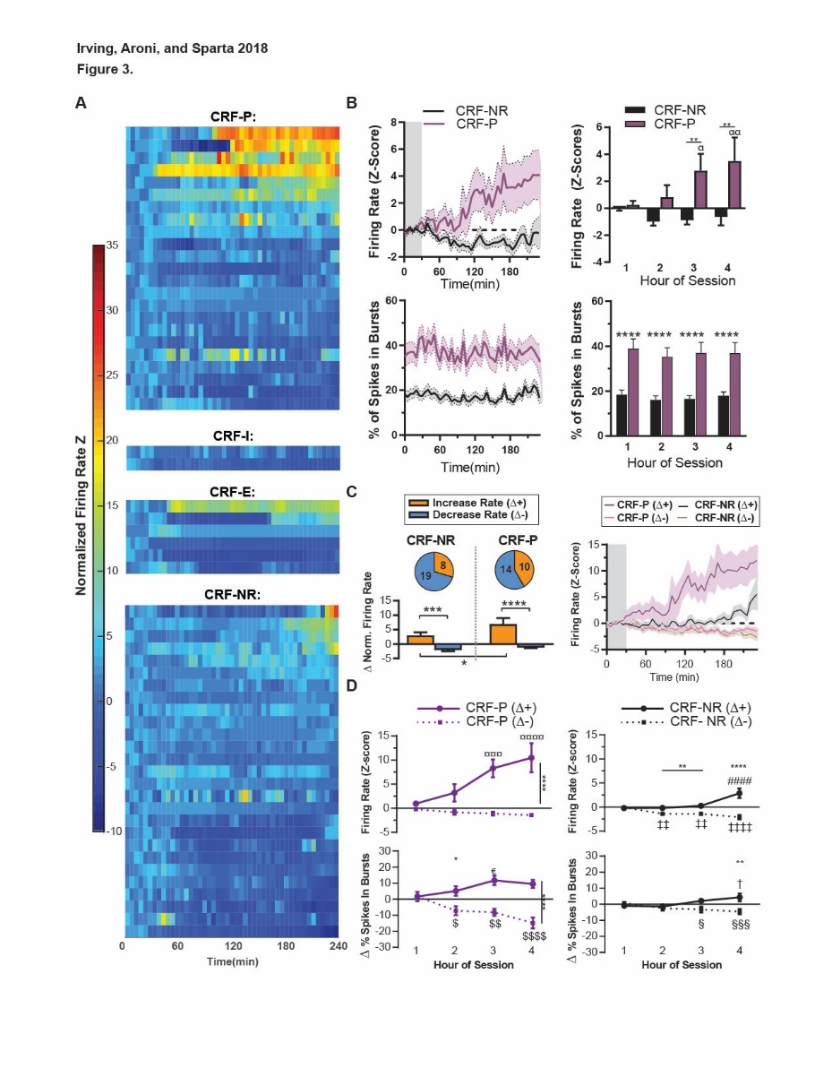

## LEGEND

Figure 3. CRF-P Neurons increase firing activity during ethanol sessions, with heterogeneous sub-types. **A)** Normalized Firing Rate Z-Scores were calculated using the first 30 mins as the baseline period for calculating the mean and std used to calculate Z-scores for the full-session. Z-scores are shown in color, with each horizontal line is one unit’s activity for the 4-hour drinking session. Units are grouped by lick-response type and then ordered from top-bottom by rate change (hour 4 – hour 1). **B)** **Left**: Average normalized firing rates and percentage of spikes in bursts calculated in 5 min bins. **Right**: Hourly averages of the same activity used for statistical analysis. **Right, top:** CRF-P units had a higher firing rate vs CRF-NR units (main effect of CRF type: F(1, 49) = 7.957, p=.0069; hour: F(3, 147) = 2.545, p=.0583; CRF-type by hour interaction (F(3, 147) = 3.924, p=.0099). **p<.01, 2way ANOVA. Post-hoc tests show that CRF-P units increased throughout the session with significantly higher rates by hours 3 and 4 (ααp<.01, αp<.05, Tukey’s tests), whereas CRF-NR did not change across hours. **Right, bottom:** CRF-P units also had higher % of spikes in bursts (F(1, 49) = 21.6, p<.0001), but did not change over the session (F(3, 147) = 1.775, p=.1545). ****p<.0001, 2way ANOVA. **C) Left:** Pie charts and bar graphs show how units were sorted by change in firing rate (hour 4 – hour 1). CRF-NR and CRF-P were separated into two statistically different subtypes that increased firing rate (Δ+) and decreased rate (Δ-) respectively (ethanol response: F(1, 46) = 7.019, p=.0110; CRF-type: F(1, 46) = 55.06, p<.0001). ****p<.0001, ***p<.001, *p<.01, Sidak’s multiple comparison test. **Right:** The average normalized firing of each CRF sub-types: CRF-NR(Δ+) (n=8), CRF-NR(Δ-) (n=19), CRF-P(Δ+) (n=9), CRF-P(Δ-) (n=14). **D**) **Left, top**: CRF-P(Δ-) and CRF-P(Δ+) firing rates were significantly distinct ( F(1, 22) = 32.86, p<.0001) for hours 3 and 4 (Sidak’s test: ****p<.0001). CRF-P(Δ+) increased throughout the sessions with hours 1 and 2 distinct from 3 and 4 (¤¤¤¤p<.0001, ¤¤¤p<.001, Tukey’s tests), but CRF-P(Δ-) did not change. **Left, bottom**: CRF-P subtypes had a significantly different change in % of spikes in bursts for hours 2-4 (F (1, 22) = 22.73, Sidak’s test: ****p<.0001, ) with a significant hour by sub-type interaction (F(3, 66) = 11.98, p<.0001). CRF-P(Δ+) changed from hour 1 vs hour 3(€p<.05, Tukey’s test), whereas CRF-P(Δ-) changed from hour 1 vs 2-4 ($$$$p<.0001, $$p<.01, $p<.05, Tukey’s tests). **Right, top:** CRF-NR(Δ+) and CRF-NR(Δ-) were significantly different (F(1, 26) = 34.41, p<.0001) for hours 2-4 (Sidak’s test: ****p<.0001, **p<.01). CRF-NR(Δ+) increased firing rate by hour 4 vs hours 1-3 (Tukey’s tests: ####p<.0001). CRF-NR(Δ-) had lower firing rates in hours 2-4 vs hour 1 (Tukey’s test: ‡‡‡‡p<.0001, ‡‡p<.01). **Right, bottom:** While CRF-NR subtypes did not have a significant main effect of sub-type (F(1, 25) = 3.071, p=.0920) or hour (F(3, 75) = 0.9743, p=.4095), there was a significant sub-type by hour interaction (F(3, 75) = 7.535, p=.0002). Post-hoc tests show that CRF-NR(Δ-) units decreased % of spikes in bursts from hour 1 to hours 3 and 4 (Tukey’s tests: §§§p<.001, §p<.05) and CRF-NR(Δ+) units increased from hours 1 and 2 to hour 4 (Tukey’s tests: †p<.05).

## STATISTICS

~~[Prism File](https://www.dropbox.com/s/hzzu4ymmcg8ms65/FIG_OutREm_NormFiring-Bar%20Graphs.pzfx?dl=0)~~

[New Prism File](https://www.dropbox.com/s/tjiud5c1pmswmc9/FIG3_NewLick_NormFiring%20%2B%20STATS.pzfx?dl=0)

### Firing Rate Z-scores [New Licks]:

|  |  |  |  |  |  |
| --- | --- | --- | --- | --- | --- |
| Source of Variation | % of total variation | P value | P value summary | Significant? |  |
| Interaction | 3.037 | 0.0099 | ** | Yes |  |
| Time | 1.97 | 0.0583 | ns | No |  |
| Unit Type | 8.006 | 0.0069 | ** | Yes |  |
| Subjects (matching) | 49.3 | <0.0001 | **** | Yes |  |
|  |  |  |  |  |  |
| ANOVA table | SS | DF | MS | F (DFn, DFd) | P value |
| Interaction | 119.2 | 3 | 39.74 | F (3, 147) = 3.924 | P=0.0099 |
| Time | 77.34 | 3 | 25.78 | F (3, 147) = 2.545 | P=0.0583 |
| Unit Type | 314.3 | 1 | 314.3 | F (1, 49) = 7.957 | P=0.0069 |
| Subjects (matching) | 1936 | 49 | 39.5 | F (49, 147) = 3.9 | P<0.0001 |
| Residual | 1489 | 147 | 10.13 |  |  |

|  |  |  |  |  |  |
| --- | --- | --- | --- | --- | --- |
| Sidak's multiple comparisons test | Mean Diff. | 95.00% CI of diff. | Significant? | Summary | Adjusted P Value |
|  |  |  |  |  |  |
| CRF-NR - CRF-P |  |  |  |  |  |
| 1 | -0.3055 | -3.254 to 2.642 | No | ns | 0.9982 |
| 2 | -1.816 | -4.764 to 1.132 | No | ns | 0.4089 |
| 3 | -3.682 | -6.63 to -0.7342 | Yes | ** | 0.0078 |
| 4 | -4.144 | -7.092 to -1.196 | Yes | ** | 0.0020 |

|  |  |  |  |  |  |
| --- | --- | --- | --- | --- | --- |
| Tukey's multiple comparisons test | Mean Diff. | 95.00% CI of diff. | Significant? | Summary | Adjusted P Value |
|  |  |  |  |  |  |
| CRF-NR |  |  |  |  |  |
| 1 vs. 2 | 0.9335 | -1.317 to 3.184 | No | ns | 0.7036 |
| 1 vs. 3 | 0.8386 | -1.412 to 3.089 | No | ns | 0.7677 |
| 1 vs. 4 | 0.5892 | -1.662 to 2.84 | No | ns | 0.9045 |
| 2 vs. 3 | -0.09493 | -2.346 to 2.156 | No | ns | 0.9995 |
| 2 vs. 4 | -0.3443 | -2.595 to 1.907 | No | ns | 0.9786 |
| 3 vs. 4 | -0.2494 | -2.5 to 2.001 | No | ns | 0.9916 |
|  |  |  |  |  |  |
| CRF-P |  |  |  |  |  |
| 1 vs. 2 | -0.5765 | -2.964 to 1.811 | No | ns | 0.9231 |
| 1 vs. 3 | -2.538 | -4.925 to -0.1507 | Yes | * | 0.0324 |
| 1 vs. 4 | -3.249 | -5.637 to -0.862 | Yes | ** | 0.0030 |
| 2 vs. 3 | -1.962 | -4.349 to 0.4258 | No | ns | 0.1469 |
| 2 vs. 4 | -2.673 | -5.06 to -0.2855 | Yes | * | 0.0215 |
| 3 vs. 4 | -0.7113 | -3.099 to 1.676 | No | ns | 0.8660 |

### % of Spikes in Bursts:

|  |  |  |  |  |  |
| --- | --- | --- | --- | --- | --- |
| Two-way RM ANOVA | Matching: Stacked |  |  |  |  |
| Alpha | 0.05 |  |  |  |  |
|  |  |  |  |  |  |
| Source of Variation | % of total variation | P value | P value summary | Significant? |  |
| Interaction | 0.03895 | 0.8922 | ns | No |  |
| Hour | 0.3359 | 0.1545 | ns | No |  |
| Unit Type | 27.64 | <0.0001 | **** | Yes |  |
| Subjects (matching) | 62.72 | <0.0001 | **** | Yes |  |
|  |  |  |  |  |  |
| ANOVA table | SS | DF | MS | F (DFn, DFd) | P value |
| Interaction | 27.99 | 3 | 9.329 | F (3, 147) = 0.2058 | P=0.8922 |
| Hour | 241.4 | 3 | 80.46 | F (3, 147) = 1.775 | P=0.1545 |
| Unit Type | 19865 | 1 | 19865 | F (1, 49) = 21.6 | P<0.0001 |
| Subjects (matching) | 45069 | 49 | 919.8 | F (49, 147) = 20.29 | P<0.0001 |
| Residual | 6663 | 147 | 45.33 |  |  |

|  |  |  |  |  |  |
| --- | --- | --- | --- | --- | --- |
| Sidak's multiple comparisons test | Mean Diff. | 95.00% CI of diff. | Significant? | Summary | Adjusted P Value |
|  |  |  |  |  |  |
| CRF-NR - CRF-P |  |  |  |  |  |
| Hour 1 | -20.54 | -31.99 to -9.077 | Yes | **** | <0.0001 |
| Hour 2 | -19.13 | -30.59 to -7.671 | Yes | *** | 0.0002 |
| Hour 3 | -20.48 | -31.94 to -9.024 | Yes | **** | <0.0001 |
| Hour 4 | -18.93 | -30.39 to -7.476 | Yes | *** | 0.0002 |

### RateSplits – Change in Rate Bar Graphs [CRF-P vs CRF-NR]

|  |  |  |  |  |  |
| --- | --- | --- | --- | --- | --- |
| Table Analyzed | CRF-P vs CRF-NR Change in Firing Rate TRANSPOSE |  |  |  |  |
|  |  |  |  |  |  |
| Two-way ANOVA | Ordinary |  |  |  |  |
| Alpha | 0.05 |  |  |  |  |
|  |  |  |  |  |  |
| Source of Variation | % of total variation | P value | P value summary | Significant? |  |
| Interaction | 2.443 | 0.1042 | ns | No |  |
| Ethanol Response | 6.241 | 0.0110 | * | Yes |  |
| CRF Type | 48.95 | <0.0001 | **** | Yes |  |
|  |  |  |  |  |  |
| ANOVA table | SS (Type III) | DF | MS | F (DFn, DFd) | P value |
| Interaction | 24.92 | 1 | 24.92 | F (1, 46) = 2.748 | P=0.1042 |
| Ethanol Response | 63.66 | 1 | 63.66 | F (1, 46) = 7.019 | P=0.0110 |
| CRF Type | 499.3 | 1 | 499.3 | F (1, 46) = 55.06 | P<0.0001 |
| Residual | 417.2 | 46 | 9.069 |  |  |

|  |  |  |  |  |  |
| --- | --- | --- | --- | --- | --- |
| Sidak's multiple comparisons test | Mean Diff. | 95.00% CI of diff. | Significant? | Summary | Adjusted P Value |
|  |  |  |  |  |  |
| EE - EI |  |  |  |  |  |
| CRF-NR | 5.207 | 2.273 to 8.141 | Yes | *** | 0.0003 |
| CRF-P | 8.203 | 5.229 to 11.18 | Yes | **** | <0.0001 |

|  |  |  |  |  |  |
| --- | --- | --- | --- | --- | --- |
| Sidak's multiple comparisons test | Mean Diff. | 95.00% CI of diff. | Significant? | Summary | Adjusted P Value |
|  |  |  |  |  |  |
| CRF-NR - CRF-P |  |  |  |  |  |
| EE | -3.892 | -7.275 to -0.5093 | Yes | * | 0.0213 |
| EI | -0.8962 | -3.348 to 1.556 | No | ns | 0.6430 |

### RateSplits – Normalized Firing Rate – CRF-P

|  |  |  |  |  |  |
| --- | --- | --- | --- | --- | --- |
| Table Analyzed | NewSplit_FIG_NormRate SPLITS - 60min bin NEW 04182018 |  |  |  |  |
|  |  |  |  |  |  |
| Two-way RM ANOVA | Matching: Stacked |  |  |  |  |
| Alpha | 0.05 |  |  |  |  |
|  |  |  |  |  |  |
| Source of Variation | % of total variation | P value | P value summary | Significant? |  |
| Interaction | 13.26 | <0.0001 | **** | Yes |  |
| Hour | 8.438 | 0.0005 | *** | Yes |  |
| Unit Split Group | 32.29 | <0.0001 | **** | Yes |  |
| Subjects (matching) | 21.62 | 0.0038 | ** | Yes |  |
|  |  |  |  |  |  |
| ANOVA table | SS | DF | MS | F (DFn, DFd) | P value |
| Interaction | 421.4 | 3 | 140.5 | F (3, 66) = 10.65 | P<0.0001 |
| Hour | 268.2 | 3 | 89.41 | F (3, 66) = 6.777 | P=0.0005 |
| Unit Split Group | 1026 | 1 | 1026 | F (1, 22) = 32.86 | P<0.0001 |
| Subjects (matching) | 687.3 | 22 | 31.24 | F (22, 66) = 2.368 | P=0.0038 |
| Residual | 870.8 | 66 | 13.19 |  |  |

|  |  |  |  |  |  |
| --- | --- | --- | --- | --- | --- |
| Sidak's multiple comparisons test | Mean Diff. | 95.00% CI of diff. | Significant? | Summary | Adjusted P Value |
|  |  |  |  |  |  |
| CRF-P: EI - CRF-P: EE |  |  |  |  |  |
| 1 | -1.174 | -5.604 to 3.256 | No | ns | 0.9386 |
| 2 | -4.036 | -8.466 to 0.3943 | No | ns | 0.0883 |
| 3 | -9.381 | -13.81 to -4.951 | Yes | **** | <0.0001 |
| 4 | -11.94 | -16.37 to -7.508 | Yes | **** | <0.0001 |

|  |  |  |  |  |  |
| --- | --- | --- | --- | --- | --- |
| Tukey's multiple comparisons test | Mean Diff. | 95.00% CI of diff. | Significant? | Summary | Adjusted P Value |
|  |  |  |  |  |  |
| CRF-P: EI |  |  |  |  |  |
| 1 vs. 2 | 0.616 | -3.003 to 4.235 | No | ns | 0.9697 |
| 1 vs. 3 | 0.8815 | -2.737 to 4.5 | No | ns | 0.9179 |
| 1 vs. 4 | 1.236 | -2.383 to 4.854 | No | ns | 0.8048 |
| 2 vs. 3 | 0.2655 | -3.353 to 3.884 | No | ns | 0.9974 |
| 2 vs. 4 | 0.6198 | -2.999 to 4.238 | No | ns | 0.9691 |
| 3 vs. 4 | 0.3543 | -3.264 to 3.973 | No | ns | 0.9939 |
|  |  |  |  |  |  |
| CRF-P: EE |  |  |  |  |  |
| 1 vs. 2 | -2.246 | -6.528 to 2.036 | No | ns | 0.5146 |
| 1 vs. 3 | -7.326 | -11.61 to -3.044 | Yes | *** | 0.0002 |
| 1 vs. 4 | -9.529 | -13.81 to -5.247 | Yes | **** | <0.0001 |
| 2 vs. 3 | -5.08 | -9.361 to -0.7979 | Yes | * | 0.0137 |
| 2 vs. 4 | -7.283 | -11.56 to -3.001 | Yes | *** | 0.0002 |
| 3 vs. 4 | -2.203 | -6.485 to 2.079 | No | ns | 0.5311 |

### RateSplits – Normalized Firing Rate – CRF-NR

|  |  |  |  |  |  |
| --- | --- | --- | --- | --- | --- |
| Table Analyzed | FIG_NormRate SPLITS - 60min bin NEW 04182018 |  |  |  |  |
|  |  |  |  |  |  |
| Two-way RM ANOVA | Matching: Stacked |  |  |  |  |
| Alpha | 0.05 |  |  |  |  |
|  |  |  |  |  |  |
| Source of Variation | % of total variation | P value | P value summary | Significant? |  |
| Interaction | 14.08 | <0.0001 | **** | Yes |  |
| Hour | 3.275 | 0.0483 | * | Yes |  |
| Unit Split Group | 29.44 | <0.0001 | **** | Yes |  |
| Subjects (matching) | 22.24 | 0.0050 | ** | Yes |  |
|  |  |  |  |  |  |
| ANOVA table | SS | DF | MS | F (DFn, DFd) | P value |
| Interaction | 61.78 | 3 | 20.59 | F (3, 78) = 11.82 | P<0.0001 |
| Hour | 14.37 | 3 | 4.791 | F (3, 78) = 2.75 | P=0.0483 |
| Unit Split Group | 129.2 | 1 | 129.2 | F (1, 26) = 34.41 | P<0.0001 |
| Subjects (matching) | 97.62 | 26 | 3.755 | F (26, 78) = 2.155 | P=0.0050 |
| Residual | 135.9 | 78 | 1.742 |  |  |

|  |  |  |  |  |  |
| --- | --- | --- | --- | --- | --- |
| Sidak's multiple comparisons test | Mean Diff. | 95.00% CI of diff. | Significant? | Summary | Adjusted P Value |
|  |  |  |  |  |  |
| CRF-NR: EI - CRF-NR: EE |  |  |  |  |  |
| 1 | -0.2426 | -1.678 to 1.193 | No | ns | 0.9880 |
| 2 | -2.119 | -3.554 to -0.6833 | Yes | ** | 0.0012 |
| 3 | -1.827 | -3.263 to -0.3915 | Yes | ** | 0.0067 |
| 4 | -4.404 | -5.84 to -2.969 | Yes | **** | <0.0001 |

|  |  |  |  |  |  |
| --- | --- | --- | --- | --- | --- |
| Tukey's multiple comparisons test | Mean Diff. | 95.00% CI of diff. | Significant? | Summary | Adjusted P Value |
|  |  |  |  |  |  |
| CRF-NR: EI |  |  |  |  |  |
| 1 vs. 2 | 1.34 | 0.2884 to 2.391 | Yes | ** | 0.0068 |
| 1 vs. 3 | 1.392 | 0.3408 to 2.444 | Yes | ** | 0.0046 |
| 1 vs. 4 | 2.132 | 1.081 to 3.184 | Yes | **** | <0.0001 |
| 2 vs. 3 | 0.05234 | -0.9992 to 1.104 | No | ns | 0.9992 |
| 2 vs. 4 | 0.7921 | -0.2594 to 1.844 | No | ns | 0.2050 |
| 3 vs. 4 | 0.7398 | -0.3118 to 1.791 | No | ns | 0.2592 |
|  |  |  |  |  |  |
| CRF-NR: EE |  |  |  |  |  |
| 1 vs. 2 | -0.03175 | -1.652 to 1.589 | No | ns | >0.9999 |
| 1 vs. 3 | -0.4764 | -2.097 to 1.144 | No | ns | 0.8666 |
| 1 vs. 4 | -3.075 | -4.696 to -1.455 | Yes | **** | <0.0001 |
| 2 vs. 3 | -0.4447 | -2.065 to 1.176 | No | ns | 0.8884 |
| 2 vs. 4 | -3.043 | -4.664 to -1.423 | Yes | **** | <0.0001 |
| 3 vs. 4 | -2.599 | -4.219 to -0.9782 | Yes | *** | 0.0004 |

### RateSplits – CHANGE IN % SPIKES - CRF-P: (Δ-) vs (Δ+)

|  |  |  |  |  |  |
| --- | --- | --- | --- | --- | --- |
| Table Analyzed | *Change*HourAvgNewSplit_percBurst_hour avg BARS |  |  |  |  |
|  |  |  |  |  |  |
| Two-way RM ANOVA | Matching: Stacked |  |  |  |  |
| Alpha | 0.05 |  |  |  |  |
|  |  |  |  |  |  |
| Source of Variation | % of total variation | P value | P value summary | Significant? |  |
| Interaction | 12.87 | <0.0001 | **** | Yes |  |
| Hour | 2.139 | 0.1239 | ns | No |  |
| Unit Type | 30.45 | <0.0001 | **** | Yes |  |
| Subjects (matching) | 29.47 | <0.0001 | **** | Yes |  |
|  |  |  |  |  |  |
| ANOVA table | SS | DF | MS | F (DFn, DFd) | P value |
| Interaction | 1980 | 3 | 660 | F (3, 66) = 11.98 | P<0.0001 |
| Hour | 329 | 3 | 109.7 | F (3, 66) = 1.991 | P=0.1239 |
| Unit Type | 4683 | 1 | 4683 | F (1, 22) = 22.73 | P<0.0001 |
| Subjects (matching) | 4532 | 22 | 206 | F (22, 66) = 3.74 | P<0.0001 |
| Residual | 3636 | 66 | 55.09 |  |  |

|  |  |  |  |  |  |
| --- | --- | --- | --- | --- | --- |
| Sidak's multiple comparisons test | Mean Diff. | 95.00% CI of diff. | Significant? | Summary | Adjusted P Value |
|  |  |  |  |  |  |
| CRF-P: EI - CRF-P: EE |  |  |  |  |  |
| Hour 1 | -0.04565 | -10.19 to 10.1 | No | ns | >0.9999 |
| Hour 2 | -12.34 | -22.49 to -2.201 | Yes | * | 0.0105 |
| Hour 3 | -19.95 | -30.09 to -9.805 | Yes | **** | <0.0001 |
| Hour 4 | -24.33 | -34.47 to -14.19 | Yes | **** | <0.0001 |

|  |  |  |  |  |  |
| --- | --- | --- | --- | --- | --- |
| Tukey's multiple comparisons test | Mean Diff. | 95.00% CI of diff. | Significant? | Summary | Adjusted P Value |
|  |  |  |  |  |  |
| CRF-P: EI |  |  |  |  |  |
| Hour 1 vs. Hour 2 | 8.845 | 1.451 to 16.24 | Yes | * | 0.0127 |
| Hour 1 vs. Hour 3 | 9.843 | 2.449 to 17.24 | Yes | ** | 0.0044 |
| Hour 1 vs. Hour 4 | 16.48 | 9.085 to 23.87 | Yes | **** | <0.0001 |
| Hour 2 vs. Hour 3 | 0.9985 | -6.395 to 8.392 | No | ns | 0.9844 |
| Hour 2 vs. Hour 4 | 7.635 | 0.2407 to 15.03 | Yes | * | 0.0404 |
| Hour 3 vs. Hour 4 | 6.636 | -0.7578 to 14.03 | No | ns | 0.0939 |
|  |  |  |  |  |  |
| CRF-P: EE |  |  |  |  |  |
| Hour 1 vs. Hour 2 | -3.455 | -12.2 to 5.294 | No | ns | 0.7262 |
| Hour 1 vs. Hour 3 | -10.06 | -18.81 to -1.311 | Yes | * | 0.0179 |
| Hour 1 vs. Hour 4 | -7.806 | -16.55 to 0.9428 | No | ns | 0.0969 |
| Hour 2 vs. Hour 3 | -6.605 | -15.35 to 2.144 | No | ns | 0.2022 |
| Hour 2 vs. Hour 4 | -4.351 | -13.1 to 4.397 | No | ns | 0.5594 |
| Hour 3 vs. Hour 4 | 2.254 | -6.495 to 11 | No | ns | 0.9047 |

EVEN WITH A ONE WAY RM ANOVA (FRIEDMAN TEST) ONLY HR1 VS HR4 for CRF-P:EE IS SIG:

|  |  |
| --- | --- |
| Table Analyzed | *Change*HourAvgNewSplit_percBurst_hour avg BARS-TRANS |
|  |  |
| Friedman test |  |
| P value | 0.0053 |
| Exact or approximate P value? | Approximate |
| P value summary | ** |
| Are means signif. different? (P < 0.05) | Yes |
| Number of groups | 4 |
| Friedman statistic | 12.72 |

|  |  |  |  |  |  |
| --- | --- | --- | --- | --- | --- |
| Dunn's multiple comparisons test | Rank sum diff. | Significant? | Summary | Adjusted P Value |  |
|  |  |  |  |  |  |
| CRF-P: EE-Hour 1 vs. CRF-P: EE-Hour 2 | -10 | No | ns | 0.4996 | M-N |
| CRF-P: EE-Hour 1 vs. CRF-P: EE-Hour 3 | -20 | Yes | ** | 0.0032 | M-O |
| CRF-P: EE-Hour 1 vs. CRF-P: EE-Hour 4 | -14 | No | ns | 0.0919 | M-P |
| CRF-P: EE-Hour 2 vs. CRF-P: EE-Hour 3 | -10 | No | ns | 0.4996 | N-O |
| CRF-P: EE-Hour 2 vs. CRF-P: EE-Hour 4 | -4 | No | ns | >0.9999 | N-P |
| CRF-P: EE-Hour 3 vs. CRF-P: EE-Hour 4 | 6 | No | ns | >0.9999 | O-P |

### RateSplits – CHANGE IN % SPIKES - CRF-NR: (Δ-) vs (Δ+)

|  |  |  |  |  |  |
| --- | --- | --- | --- | --- | --- |
| Table Analyzed | *Change*HourAvgNewSplit_percBurst_hour avg BARS |  |  |  |  |
|  |  |  |  |  |  |
| Two-way RM ANOVA | Matching: Stacked |  |  |  |  |
| Alpha | 0.05 |  |  |  |  |
|  |  |  |  |  |  |
| Source of Variation | % of total variation | P value | P value summary | Significant? |  |
| Interaction | 8.784 | 0.0002 | *** | Yes |  |
| Hour | 1.136 | 0.4095 | ns | No |  |
| Unit Type | 6.547 | 0.0920 | ns | No |  |
| Subjects (matching) | 53.3 | <0.0001 | **** | Yes |  |
|  |  |  |  |  |  |
| ANOVA table | SS | DF | MS | F (DFn, DFd) | P value |
| Interaction | 363.9 | 3 | 121.3 | F (3, 75) = 7.535 | P=0.0002 |
| Hour | 47.06 | 3 | 15.69 | F (3, 75) = 0.9743 | P=0.4095 |
| Unit Type | 271.3 | 1 | 271.3 | F (1, 25) = 3.071 | P=0.0920 |
| Subjects (matching) | 2208 | 25 | 88.32 | F (25, 75) = 5.486 | P<0.0001 |
| Residual | 1208 | 75 | 16.1 |  |  |

|  |  |  |  |  |  |
| --- | --- | --- | --- | --- | --- |
| Sidak's multiple comparisons test | Mean Diff. | 95.00% CI of diff. | Significant? | Summary | Adjusted P Value |
|  |  |  |  |  |  |
| CRF-NR: EI - CRF-NR: EE |  |  |  |  |  |
| Hour 1 | 1.566 | -4.682 to 7.814 | No | ns | 0.9497 |
| Hour 2 | -1.116 | -7.364 to 5.132 | No | ns | 0.9853 |
| Hour 3 | -5.376 | -11.62 to 0.8724 | No | ns | 0.1199 |
| Hour 4 | -8.957 | -15.21 to -2.709 | Yes | ** | 0.0018 |

|  |  |  |  |  |  |
| --- | --- | --- | --- | --- | --- |
| Tukey's multiple comparisons test | Mean Diff. | 95.00% CI of diff. | Significant? | Summary | Adjusted P Value |
|  |  |  |  |  |  |
| CRF-NR: EI |  |  |  |  |  |
| Hour 1 vs. Hour 2 | 3.096 | -0.325 to 6.516 | No | ns | 0.0902 |
| Hour 1 vs. Hour 3 | 3.964 | 0.5436 to 7.385 | Yes | * | 0.0166 |
| Hour 1 vs. Hour 4 | 5.235 | 1.814 to 8.655 | Yes | *** | 0.0008 |
| Hour 2 vs. Hour 3 | 0.8686 | -2.552 to 4.289 | No | ns | 0.9091 |
| Hour 2 vs. Hour 4 | 2.139 | -1.282 to 5.56 | No | ns | 0.3612 |
| Hour 3 vs. Hour 4 | 1.27 | -2.15 to 4.691 | No | ns | 0.7636 |
|  |  |  |  |  |  |
| CRF-NR: EE |  |  |  |  |  |
| Hour 1 vs. Hour 2 | 0.4137 | -4.858 to 5.685 | No | ns | 0.9969 |
| Hour 1 vs. Hour 3 | -2.977 | -8.249 to 2.294 | No | ns | 0.4522 |
| Hour 1 vs. Hour 4 | -5.289 | -10.56 to -0.01718 | Yes | * | 0.0490 |
| Hour 2 vs. Hour 3 | -3.391 | -8.663 to 1.881 | No | ns | 0.3360 |
| Hour 2 vs. Hour 4 | -5.703 | -10.97 to -0.4309 | Yes | * | 0.0288 |
| Hour 3 vs. Hour 4 | -2.312 | -7.583 to 2.96 | No | ns | 0.6586 |
|  |  |  |  |  |  |

# FIGURE 4

## JPG

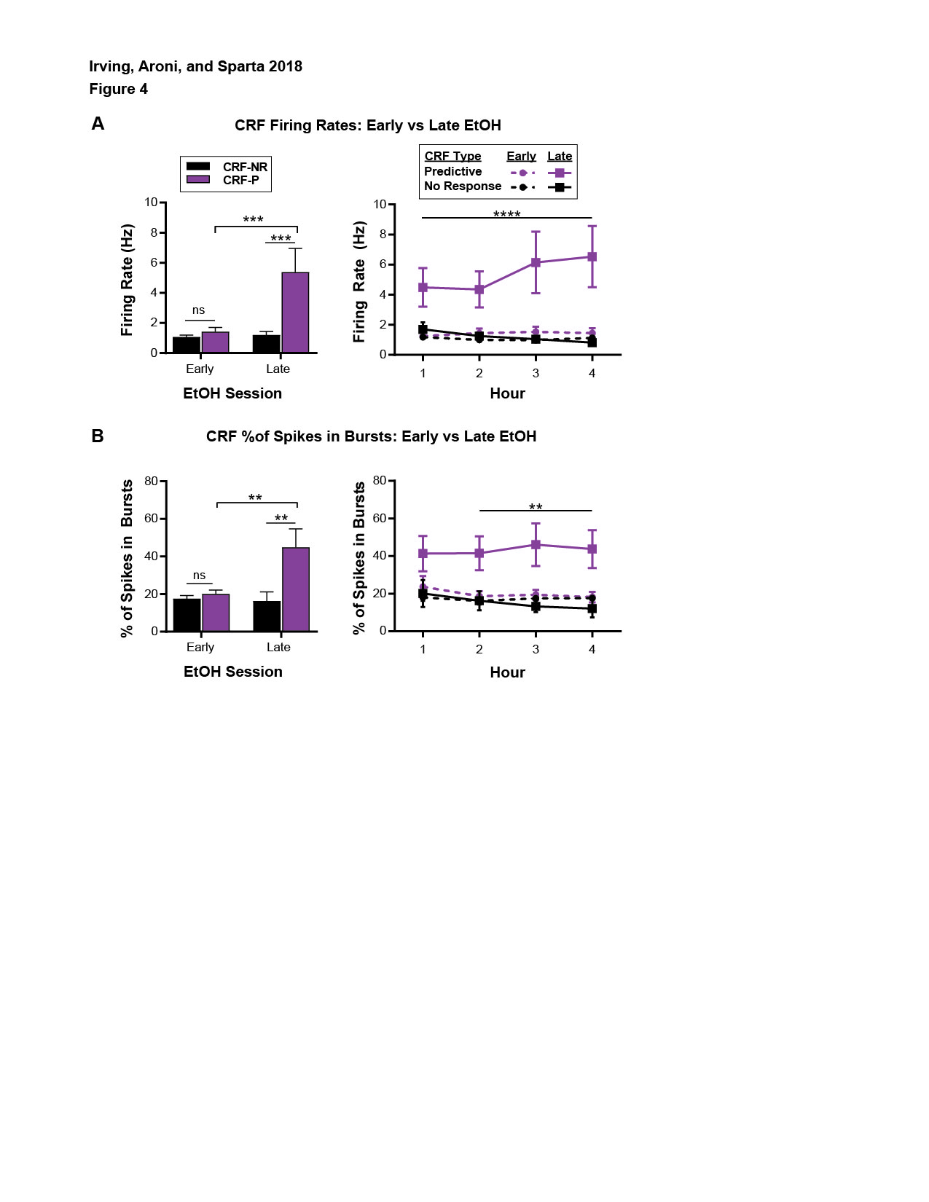

## LEGEND

Figure 4. Changes in CRF activity over repeated ethanol sessions. **A)** CRF-P increased raw firing rates after repeated ethanol sessions (main effect of ethanol session: F(1, 38) = 11.34, p=.0017; main effect of CRF type: F(1, 38) = 13.85, p=.0006; Tukey’s tests: Early vs Late CRF-P: ***p=.0005), which was absent in CRF-NR units (Tukey’s tests: Early vs Late CRF-NR: p=.9986). **B)** Similarly, CRF-P units showed a significant increase in the percentage of spikes in bursts after repeated ethanol sessions (main effect of CRF-type: F(1, 38) = 12.44, p=.0011, ethanol session: F(1, 38) = 7.138, p=.0111; Tukey’s tests: Early vs Late CRF-P: **p=.0029) and CRF-NR did not (Tukey’s tests, p=.9961).

## STATISTICS

[~~New Prism File~~](https://www.dropbox.com/s/7584y6sqyj72om1/FIG5_CeA%20CRF%20Early%20vs%20Late%20EtOH%20Sessions%20-%20Bar%20Graphs.pzfx?dl=0)  
[Prism File – Data Family Separated 09/03/18](https://www.dropbox.com/s/qcfhj6j1e7a2kay/FIG4_CRF-P%20vs%20CRF-NR%20-%20Early%20vs%20Late%20-%20Spike%20Rate%20%2B%20%25SiB.pzfx?dl=0)

### Fig 4A, Bar: CRF-P vs CRF-NR: Early vs Late - Firing Rate (Hz)

|  |  |  |  |  |  |
| --- | --- | --- | --- | --- | --- |
| Table Analyzed | NewLicks*FIG_CRF-NR vs CRF- Firing Rate - Early vs late 05022018 |  |  |  |  |
|  |  |  |  |  |  |
| Two-way ANOVA | Ordinary |  |  |  |  |
| Alpha | 0.05 |  |  |  |  |
|  |  |  |  |  |  |
| Source of Variation | % of total variation | P value | P value summary | Significant? |  |
| Interaction | 13.86 | 0.0031 | ** | Yes |  |
| Ethanol session | 15.77 | 0.0017 | ** | Yes |  |
| Cell Type | 19.25 | 0.0006 | *** | Yes |  |
|  |  |  |  |  |  |
| ANOVA table | SS (Type III) | DF | MS | F (DFn, DFd) | P value |
| Interaction | 30.48 | 1 | 30.48 | F (1, 38) = 9.967 | P=0.0031 |
| Ethanol session | 34.69 | 1 | 34.69 | F (1, 38) = 11.34 | P=0.0017 |
| Cell Type | 42.35 | 1 | 42.35 | F (1, 38) = 13.85 | P=0.0006 |
| Residual | 116.2 | 38 | 3.058 |  |  |

|  |  |  |  |  |  |
| --- | --- | --- | --- | --- | --- |
| Tukey's multiple comparisons test | Mean Diff. | 95.00% CI of diff. | Significant? | Summary | Adjusted P Value |
|  |  |  |  |  |  |
| Early:CRF-NR vs. Early:CRF-P | -0.3424 | -2.294 to 1.61 | No | ns | 0.9649 |
| **Early:CRF-NR vs. Late:CRF-NR** | **-0.1279** | **-2.303 to 2.047** | **No** | **ns** | **0.9986** |
| Early:CRF-NR vs. Late:CRF-P | -4.304 | -6.354 to -2.254 | Yes | **** | <0.0001 |
| Early:CRF-P vs. Late:CRF-NR | 0.2145 | -2.323 to 2.752 | No | ns | 0.9958 |
| **Early:CRF-P vs. Late:CRF-P** | **-3.962** | **-6.393 to -1.53** | **Yes** | **\*\*\*** | **0.0005** |
| Late:CRF-NR vs. Late:CRF-P | -4.176 | -6.79 to -1.562 | Yes | *** | 0.0007 |

### Fig 4A, Line: CRF-P vs CRF-NR: Early vs Late By Hour: Firing Rate (Hz)

|  |  |  |  |  |  |
| --- | --- | --- | --- | --- | --- |
|  |  |  |  |  |  |
| Two-way RM ANOVA | Matching: Stacked |  |  |  |  |
| Alpha | 0.05 |  |  |  |  |
|  |  |  |  |  |  |
| Source of Variation | % of total variation | P value | P value summary | Significant? |  |
| Interaction | 2.7 | <0.0001 | **** | Yes |  |
| Hour | 0.4995 | 0.0639 | ns | No |  |
| Unit Type | 42.14 | <0.0001 | **** | Yes |  |
| Subjects (matching) | 47.2 | <0.0001 | **** | Yes |  |
|  |  |  |  |  |  |
| ANOVA table | SS | DF | MS | F (DFn, DFd) | P value |
| Interaction | 26.59 | 9 | 2.954 | F (9, 114) = 4.484 | P<0.0001 |
| Hour | 4.919 | 3 | 1.64 | F (3, 114) = 2.489 | P=0.0639 |
| Unit Type | 415.1 | 3 | 138.4 | F (3, 38) = 11.31 | P<0.0001 |
| Subjects (matching) | 464.9 | 38 | 12.23 | F (38, 114) = 18.57 | P<0.0001 |
| Residual | 75.11 | 114 | 0.6588 |  |  |

**UPDATED POST HOC [Discussed @ meeting on 08/09/18]**

|  |  |  |  |  |  |  |  |  |
| --- | --- | --- | --- | --- | --- | --- | --- | --- |
|  |  |  |  |  |  |  |  |  |
| Within each row, compare columns (simple effects within rows) |  |  |  |  |  |  |  |  |
|  |  |  |  |  |  |  |  |  |
| Number of families | 4 |  |  |  |  |  |  |  |
| Number of comparisons per family | 6 |  |  |  |  |  |  |  |
| Alpha | 0.05 |  |  |  |  |  |  |  |
|  |  |  |  |  |  |  |  |  |
| Tukey's multiple comparisons test | Mean Diff. | 95.00% CI of diff. | Significant? | Summary | Adjusted P Value |  |  |  |
|  |  |  |  |  |  |  |  |  |
| Row 1 |  |  |  |  |  |  |  |  |
| CRF-NR: Early Days vs. CRF-NR: Late Days | -0.5162 | -2.783 to 1.75 | No | ns | 0.9345 |  |  |  |
| CRF-NR: Early Days vs. CRF-P: Early | -0.06464 | -2.099 to 1.97 | No | ns | 0.9998 |  |  |  |
| CRF-NR: Early Days vs. CRF-P: Late | -3.301 | -5.438 to -1.164 | Yes | *** | 0.0005 |  |  |  |
| CRF-NR: Late Days vs. CRF-P: Early | 0.4515 | -2.193 to 3.096 | No | ns | 0.9708 |  |  |  |
| CRF-NR: Late Days vs. CRF-P: Late | -2.785 | -5.509 to -0.06102 | Yes | * | 0.0430 |  |  |  |
| CRF-P: Early vs. CRF-P: Late | -3.237 | -5.771 to -0.7025 | Yes | ** | 0.0062 |  |  |  |
|  |  |  |  |  |  |  |  |  |
| Row 2 |  |  |  |  |  |  |  |  |
| CRF-NR: Early Days vs. CRF-NR: Late Days | -0.2523 | -2.519 to 2.014 | No | ns | 0.9915 |  |  |  |
| CRF-NR: Early Days vs. CRF-P: Early | -0.452 | -2.486 to 1.582 | No | ns | 0.9388 |  |  |  |
| CRF-NR: Early Days vs. CRF-P: Late | -3.356 | -5.493 to -1.219 | Yes | *** | 0.0004 |  |  |  |
| CRF-NR: Late Days vs. CRF-P: Early | -0.1997 | -2.844 to 2.444 | No | ns | 0.9973 |  |  |  |
| CRF-NR: Late Days vs. CRF-P: Late | -3.104 | -5.828 to -0.38 | Yes | * | 0.0185 |  |  |  |
| CRF-P: Early vs. CRF-P: Late | -2.904 | -5.438 to -0.3702 | Yes | * | 0.0176 |  |  |  |
|  |  |  |  |  |  |  |  |  |
| Row 3 |  |  |  |  |  |  |  |  |
| CRF-NR: Early Days vs. CRF-NR: Late Days | -0.05317 | -2.32 to 2.213 | No | ns | >0.9999 |  |  |  |
| CRF-NR: Early Days vs. CRF-P: Early | -0.5399 | -2.574 to 1.494 | No | ns | 0.9010 |  |  |  |
| CRF-NR: Early Days vs. CRF-P: Late | -5.154 | -7.291 to -3.017 | Yes | **** | <0.0001 |  |  |  |
| CRF-NR: Late Days vs. CRF-P: Early | -0.4867 | -3.131 to 2.158 | No | ns | 0.9638 |  |  |  |
| CRF-NR: Late Days vs. CRF-P: Late | -5.101 | -7.825 to -2.377 | Yes | **** | <0.0001 |  |  |  |
| CRF-P: Early vs. CRF-P: Late | -4.614 | -7.148 to -2.08 | Yes | **** | <0.0001 |  |  |  |
|  |  |  |  |  |  |  |  |  |
| Row 4 |  |  |  |  |  |  |  |  |
| CRF-NR: Early Days vs. CRF-NR: Late Days | 0.31 | -1.956 to 2.577 | No | ns | 0.9846 |  |  |  |
| CRF-NR: Early Days vs. CRF-P: Early | -0.3131 | -2.347 to 1.721 | No | ns | 0.9783 |  |  |  |
| CRF-NR: Early Days vs. CRF-P: Late | -5.405 | -7.541 to -3.268 | Yes | **** | <0.0001 |  |  |  |
| CRF-NR: Late Days vs. CRF-P: Early | -0.6231 | -3.267 to 2.021 | No | ns | 0.9281 |  |  |  |
| CRF-NR: Late Days vs. CRF-P: Late | -5.715 | -8.439 to -2.991 | Yes | **** | <0.0001 |  |  |  |
| CRF-P: Early vs. CRF-P: Late | -5.092 | -7.626 to -2.558 | Yes | **** | <0.0001 |  |  |  |
|  |  |  |  |  |  |  |  |  |
|  |  |  |  |  |  |  |  |  |
| Test details | Mean 1 | Mean 2 | Mean Diff. | SE of diff. | N1 | N2 | q | DF |
|  |  |  |  |  |  |  |  |  |
| Row 1 |  |  |  |  |  |  |  |  |
| CRF-NR: Early Days vs. CRF-NR: Late Days | 1.185 | 1.701 | -0.5162 | 0.8725 | 21 | 6 | 0.8367 | 152 |
| CRF-NR: Early Days vs. CRF-P: Early | 1.185 | 1.249 | -0.06464 | 0.7831 | 21 | 8 | 0.1167 | 152 |
| CRF-NR: Early Days vs. CRF-P: Late | 1.185 | 4.486 | -3.301 | 0.8226 | 21 | 7 | 5.675 | 152 |
| CRF-NR: Late Days vs. CRF-P: Early | 1.701 | 1.249 | 0.4515 | 1.018 | 6 | 8 | 0.6273 | 152 |
| CRF-NR: Late Days vs. CRF-P: Late | 1.701 | 4.486 | -2.785 | 1.049 | 6 | 7 | 3.756 | 152 |
| CRF-P: Early vs. CRF-P: Late | 1.249 | 4.486 | -3.237 | 0.9755 | 8 | 7 | 4.692 | 152 |
|  |  |  |  |  |  |  |  |  |
| Row 2 |  |  |  |  |  |  |  |  |
| CRF-NR: Early Days vs. CRF-NR: Late Days | 0.9963 | 1.249 | -0.2523 | 0.8725 | 21 | 6 | 0.4089 | 152 |
| CRF-NR: Early Days vs. CRF-P: Early | 0.9963 | 1.448 | -0.452 | 0.7831 | 21 | 8 | 0.8163 | 152 |
| CRF-NR: Early Days vs. CRF-P: Late | 0.9963 | 4.352 | -3.356 | 0.8226 | 21 | 7 | 5.77 | 152 |
| CRF-NR: Late Days vs. CRF-P: Early | 1.249 | 1.448 | -0.1997 | 1.018 | 6 | 8 | 0.2775 | 152 |
| CRF-NR: Late Days vs. CRF-P: Late | 1.249 | 4.352 | -3.104 | 1.049 | 6 | 7 | 4.186 | 152 |
| CRF-P: Early vs. CRF-P: Late | 1.448 | 4.352 | -2.904 | 0.9755 | 8 | 7 | 4.21 | 152 |
|  |  |  |  |  |  |  |  |  |
| Row 3 |  |  |  |  |  |  |  |  |
| CRF-NR: Early Days vs. CRF-NR: Late Days | 0.9882 | 1.041 | -0.05317 | 0.8725 | 21 | 6 | 0.08619 | 152 |
| CRF-NR: Early Days vs. CRF-P: Early | 0.9882 | 1.528 | -0.5399 | 0.7831 | 21 | 8 | 0.975 | 152 |
| CRF-NR: Early Days vs. CRF-P: Late | 0.9882 | 6.142 | -5.154 | 0.8226 | 21 | 7 | 8.86 | 152 |
| CRF-NR: Late Days vs. CRF-P: Early | 1.041 | 1.528 | -0.4867 | 1.018 | 6 | 8 | 0.6762 | 152 |
| CRF-NR: Late Days vs. CRF-P: Late | 1.041 | 6.142 | -5.101 | 1.049 | 6 | 7 | 6.879 | 152 |
| CRF-P: Early vs. CRF-P: Late | 1.528 | 6.142 | -4.614 | 0.9755 | 8 | 7 | 6.689 | 152 |
|  |  |  |  |  |  |  |  |  |
| Row 4 |  |  |  |  |  |  |  |  |
| CRF-NR: Early Days vs. CRF-NR: Late Days | 1.128 | 0.8182 | 0.31 | 0.8725 | 21 | 6 | 0.5025 | 152 |
| CRF-NR: Early Days vs. CRF-P: Early | 1.128 | 1.441 | -0.3131 | 0.7831 | 21 | 8 | 0.5654 | 152 |
| CRF-NR: Early Days vs. CRF-P: Late | 1.128 | 6.533 | -5.405 | 0.8226 | 21 | 7 | 9.292 | 152 |
| CRF-NR: Late Days vs. CRF-P: Early | 0.8182 | 1.441 | -0.6231 | 1.018 | 6 | 8 | 0.8657 | 152 |
| CRF-NR: Late Days vs. CRF-P: Late | 0.8182 | 6.533 | -5.715 | 1.049 | 6 | 7 | 7.707 | 152 |
| CRF-P: Early vs. CRF-P: Late | 1.441 | 6.533 | -5.092 | 0.9755 | 8 | 7 | 7.381 | 152 |

|  |  |  |  |  |  |
| --- | --- | --- | --- | --- | --- |
| **Tukey's multiple comparisons test** | **Mean Diff.** | **95.00% CI of diff.** | **Significant?** | **Summary** | **Adjusted P Value** |
|  |  |  |  |  |  |
| CRF-NR: Early Days |  |  |  |  |  |
| Hour 1 vs. Hour 2 | 0.1884 | -0.4647 to 0.8416 | No | ns | 0.8755 |
| Hour 1 vs. Hour 3 | 0.1965 | -0.4567 to 0.8496 | No | ns | 0.8615 |
| Hour 1 vs. Hour 4 | 0.05643 | -0.5967 to 0.7096 | No | ns | 0.9959 |
| Hour 2 vs. Hour 3 | 0.008019 | -0.6451 to 0.6611 | No | ns | >0.9999 |
| Hour 2 vs. Hour 4 | -0.132 | -0.7851 to 0.5211 | No | ns | 0.9524 |
| Hour 3 vs. Hour 4 | -0.14 | -0.7931 to 0.5131 | No | ns | 0.9439 |
|  |  |  |  |  |  |
| CRF-NR: Late Days |  |  |  |  |  |
| Hour 1 vs. Hour 2 | 0.4524 | -0.7695 to 1.674 | No | ns | 0.7694 |
| Hour 1 vs. Hour 3 | 0.6595 | -0.5624 to 1.881 | No | ns | 0.4975 |
| Hour 1 vs. Hour 4 | 0.8826 | -0.3392 to 2.105 | No | ns | 0.2409 |
| Hour 2 vs. Hour 3 | 0.2071 | -1.015 to 1.429 | No | ns | 0.9710 |
| Hour 2 vs. Hour 4 | 0.4303 | -0.7916 to 1.652 | No | ns | 0.7952 |
| Hour 3 vs. Hour 4 | 0.2232 | -0.9987 to 1.445 | No | ns | 0.9642 |
|  |  |  |  |  |  |
| CRF-P: Early |  |  |  |  |  |
| Hour 1 vs. Hour 2 | -0.1989 | -1.257 to 0.8593 | No | ns | 0.9611 |
| Hour 1 vs. Hour 3 | -0.2788 | -1.337 to 0.7794 | No | ns | 0.9019 |
| Hour 1 vs. Hour 4 | -0.192 | -1.25 to 0.8662 | No | ns | 0.9649 |
| Hour 2 vs. Hour 3 | -0.07986 | -1.138 to 0.9783 | No | ns | 0.9973 |
| Hour 2 vs. Hour 4 | 0.006927 | -1.051 to 1.065 | No | ns | >0.9999 |
| Hour 3 vs. Hour 4 | 0.08679 | -0.9714 to 1.145 | No | ns | 0.9965 |
|  |  |  |  |  |  |
| CRF-P: Late |  |  |  |  |  |
| Hour 1 vs. Hour 2 | 0.1334 | -0.9978 to 1.265 | No | ns | 0.9899 |
| Hour 1 vs. Hour 3 | -1.656 | -2.787 to -0.525 | Yes | ** | 0.0012 |
| Hour 1 vs. Hour 4 | -2.047 | -3.178 to -0.9158 | Yes | **** | <0.0001 |
| Hour 2 vs. Hour 3 | -1.79 | -2.921 to -0.6584 | Yes | *** | 0.0004 |
| Hour 2 vs. Hour 4 | -2.18 | -3.312 to -1.049 | Yes | **** | <0.0001 |
| Hour 3 vs. Hour 4 | -0.3908 | -1.522 to 0.7405 | No | ns | 0.8045 |

### Fig 4B, Bars: CRF-P vs CRF-NR: Early vs Late - % Spikes In Bursts

|  |  |  |  |  |  |
| --- | --- | --- | --- | --- | --- |
| Table Analyzed | FIG_CRF-NR vs CRF-P PercBurst- Early vs late -Bar |  |  |  |  |
|  |  |  |  |  |  |
| Two-way ANOVA | Ordinary |  |  |  |  |
| Alpha | 0.05 |  |  |  |  |
|  |  |  |  |  |  |
| Source of Variation | % of total variation | P value | P value summary | Significant? |  |
| Interaction | 13.62 | 0.0052 | ** | Yes |  |
| EarlyVsLate | 11.03 | 0.0111 | * | Yes |  |
| Unit Type | 19.23 | 0.0011 | ** | Yes |  |
|  |  |  |  |  |  |
| ANOVA table | SS (Type III) | DF | MS | F (DFn, DFd) | P value |
| Interaction | 1412 | 1 | 1412 | F (1, 38) = 8.808 | P=0.0052 |
| EarlyVsLate | 1144 | 1 | 1144 | F (1, 38) = 7.138 | P=0.0111 |
| Unit Type | 1994 | 1 | 1994 | F (1, 38) = 12.44 | P=0.0011 |
| Residual | 6090 | 38 | 160.3 |  |  |

|  |  |  |  |  |  |
| --- | --- | --- | --- | --- | --- |
| Compare cell means regardless of rows and columns |  |  |  |  |  |
|  |  |  |  |  |  |
| Number of families | 1 |  |  |  |  |
| Number of comparisons per family | 6 |  |  |  |  |
| Alpha | 0.05 |  |  |  |  |
|  |  |  |  |  |  |
| Tukey's multiple comparisons test | Mean Diff. | 95.00% CI of diff. | Significant? | Summary | Adjusted P Value |
|  |  |  |  |  |  |
| Early:CRF-NR vs. Early:CRF-P | -2.459 | -16.59 to 11.67 | No | ns | 0.9657 |
| Early:CRF-NR vs. Late:CRF-NR | 1.302 | -14.44 to 17.05 | No | ns | 0.9961 |
| Early:CRF-NR vs. Late:CRF-P | -27.25 | -42.09 to -12.4 | Yes | **** | <0.0001 |
| Early:CRF-P vs. Late:CRF-NR | 3.761 | -14.61 to 22.13 | No | ns | 0.9460 |
| Early:CRF-P vs. Late:CRF-P | -24.79 | -42.39 to -7.185 | Yes | ** | 0.0029 |
| Late:CRF-NR vs. Late:CRF-P | -28.55 | -47.47 to -9.626 | Yes | ** | 0.0013 |

### Fig 4B, Line: CRF-P vs CRF-NR: Early vs Late - % Spikes In Bursts

|  |  |  |  |  |  |
| --- | --- | --- | --- | --- | --- |
| Table Analyzed | FIG_CRF-NR vs CRF-P PercBurst- Early vs late - LINES |  |  |  |  |
|  |  |  |  |  |  |
| Two-way RM ANOVA | Matching: Stacked |  |  |  |  |
| Alpha | 0.05 |  |  |  |  |
|  |  |  |  |  |  |
| Source of Variation | % of total variation | P value | P value summary | Significant? |  |
| Interaction | 0.8743 | 0.4817 | ns | No |  |
| Hour | 0.3907 | 0.2849 | ns | No |  |
| Unit Type | 34.89 | 0.0002 | *** | Yes |  |
| Subjects (matching) | 52.31 | <0.0001 | **** | Yes |  |
|  |  |  |  |  |  |
| ANOVA table | SS | DF | MS | F (DFn, DFd) | P value |
| Interaction | 389.5 | 9 | 43.28 | F (9, 114) = 0.9542 | P=0.4817 |
| Hour | 174.1 | 3 | 58.02 | F (3, 114) = 1.279 | P=0.2849 |
| Unit Type | 15541 | 3 | 5180 | F (3, 38) = 8.447 | P=0.0002 |
| Subjects (matching) | 23304 | 38 | 613.3 | F (38, 114) = 13.52 | P<0.0001 |
| Residual | 5170 | 114 | 45.35 |  |  |

|  |  |  |  |  |  |
| --- | --- | --- | --- | --- | --- |
| Tukey's multiple comparisons test | Mean Diff. | 95.00% CI of diff. | Significant? | Summary | Adjusted P Value |
|  |  |  |  |  |  |
| CRF-NR: Early Days |  |  |  |  |  |
| 1 vs. 2 | 1.862 | -3.557 to 7.281 | No | ns | 0.8069 |
| 1 vs. 3 | 0.4754 | -4.943 to 5.894 | No | ns | 0.9958 |
| 1 vs. 4 | 0.4337 | -4.985 to 5.852 | No | ns | 0.9968 |
| 2 vs. 3 | -1.387 | -6.805 to 4.032 | No | ns | 0.9092 |
| 2 vs. 4 | -1.428 | -6.847 to 3.99 | No | ns | 0.9018 |
| 3 vs. 4 | -0.04172 | -5.46 to 5.377 | No | ns | >0.9999 |
|  |  |  |  |  |  |
| CRF-NR: Late Days |  |  |  |  |  |
| 1 vs. 2 | 3.837 | -6.3 to 13.97 | No | ns | 0.7571 |
| 1 vs. 3 | 6.92 | -3.217 to 17.06 | No | ns | 0.2883 |
| 1 vs. 4 | 8.007 | -2.131 to 18.14 | No | ns | 0.1729 |
| 2 vs. 3 | 3.083 | -7.055 to 13.22 | No | ns | 0.8576 |
| 2 vs. 4 | 4.169 | -5.968 to 14.31 | No | ns | 0.7071 |
| 3 vs. 4 | 1.087 | -9.051 to 11.22 | No | ns | 0.9923 |
|  |  |  |  |  |  |
| CRF-P: Early |  |  |  |  |  |
| 1 vs. 2 | 5.096 | -3.683 to 13.88 | No | ns | 0.4329 |
| 1 vs. 3 | 4.335 | -4.444 to 13.11 | No | ns | 0.5728 |
| 1 vs. 4 | 5.58 | -3.199 to 14.36 | No | ns | 0.3511 |
| 2 vs. 3 | -0.7611 | -9.54 to 8.018 | No | ns | 0.9959 |
| 2 vs. 4 | 0.4846 | -8.295 to 9.264 | No | ns | 0.9989 |
| 3 vs. 4 | 1.246 | -7.534 to 10.02 | No | ns | 0.9826 |
|  |  |  |  |  |  |
| CRF-P: Late |  |  |  |  |  |
| 1 vs. 2 | -0.1146 | -9.5 to 9.271 | No | ns | >0.9999 |
| 1 vs. 3 | -4.709 | -14.09 to 4.676 | No | ns | 0.5596 |
| 1 vs. 4 | -2.346 | -11.73 to 7.039 | No | ns | 0.9147 |
| 2 vs. 3 | -4.594 | -13.98 to 4.791 | No | ns | 0.5798 |
| 2 vs. 4 | -2.232 | -11.62 to 7.154 | No | ns | 0.9255 |
| 3 vs. 4 | 2.363 | -7.023 to 11.75 | No | ns | 0.9131 |

**UPDATED POST HOC [Discussed @ meeting on 08/09/18]**

|  |  |  |  |  |  |  |  |  |
| --- | --- | --- | --- | --- | --- | --- | --- | --- |
| Within each row, compare columns (simple effects within rows) |  |  |  |  |  |  |  |  |
|  |  |  |  |  |  |  |  |  |
| Number of families | 4 |  |  |  |  |  |  |  |
| Number of comparisons per family | 6 |  |  |  |  |  |  |  |
| Alpha | 0.05 |  |  |  |  |  |  |  |
|  |  |  |  |  |  |  |  |  |
| Tukey's multiple comparisons test | Mean Diff. | 95.00% CI of diff. | Significant? | Summary | Adjusted P Value |  |  |  |
|  |  |  |  |  |  |  |  |  |
| 1 |  |  |  |  |  |  |  |  |
| CRF-NR: Early Days vs. CRF-NR: Late Days | -2.115 | -18.57 to 14.34 | No | ns | 0.9871 |  |  |  |
| CRF-NR: Early Days vs. CRF-P: Early | -5.727 | -20.5 to 9.044 | No | ns | 0.7455 |  |  |  |
| CRF-NR: Early Days vs. CRF-P: Late | -23.36 | -38.87 to -7.841 | Yes | *** | 0.0008 |  |  |  |
| CRF-NR: Late Days vs. CRF-P: Early | -3.612 | -22.81 to 15.59 | No | ns | 0.9615 |  |  |  |
| CRF-NR: Late Days vs. CRF-P: Late | -21.24 | -41.02 to -1.462 | Yes | * | 0.0300 |  |  |  |
| CRF-P: Early vs. CRF-P: Late | -17.63 | -36.03 to 0.7704 | No | ns | 0.0657 |  |  |  |
|  |  |  |  |  |  |  |  |  |
| 2 |  |  |  |  |  |  |  |  |
| CRF-NR: Early Days vs. CRF-NR: Late Days | -0.1397 | -16.6 to 16.32 | No | ns | >0.9999 |  |  |  |
| CRF-NR: Early Days vs. CRF-P: Early | -2.493 | -17.27 to 12.28 | No | ns | 0.9717 |  |  |  |
| CRF-NR: Early Days vs. CRF-P: Late | -25.33 | -40.85 to -9.817 | Yes | *** | 0.0002 |  |  |  |
| CRF-NR: Late Days vs. CRF-P: Early | -2.354 | -21.55 to 16.85 | No | ns | 0.9888 |  |  |  |
| CRF-NR: Late Days vs. CRF-P: Late | -25.19 | -44.97 to -5.414 | Yes | ** | 0.0064 |  |  |  |
| CRF-P: Early vs. CRF-P: Late | -22.84 | -41.24 to -4.44 | Yes | ** | 0.0083 |  |  |  |
|  |  |  |  |  |  |  |  |  |
| 3 |  |  |  |  |  |  |  |  |
| CRF-NR: Early Days vs. CRF-NR: Late Days | 4.33 | -12.13 to 20.79 | No | ns | 0.9033 |  |  |  |
| CRF-NR: Early Days vs. CRF-P: Early | -1.868 | -16.64 to 12.9 | No | ns | 0.9877 |  |  |  |
| CRF-NR: Early Days vs. CRF-P: Late | -28.54 | -44.06 to -13.03 | Yes | **** | <0.0001 |  |  |  |
| CRF-NR: Late Days vs. CRF-P: Early | -6.197 | -25.4 to 13 | No | ns | 0.8361 |  |  |  |
| CRF-NR: Late Days vs. CRF-P: Late | -32.87 | -52.65 to -13.09 | Yes | *** | 0.0002 |  |  |  |
| CRF-P: Early vs. CRF-P: Late | -26.67 | -45.08 to -8.273 | Yes | ** | 0.0013 |  |  |  |
|  |  |  |  |  |  |  |  |  |
| 4 |  |  |  |  |  |  |  |  |
| CRF-NR: Early Days vs. CRF-NR: Late Days | 5.458 | -11 to 21.92 | No | ns | 0.8247 |  |  |  |
| CRF-NR: Early Days vs. CRF-P: Early | -0.5805 | -15.35 to 14.19 | No | ns | 0.9996 |  |  |  |
| CRF-NR: Early Days vs. CRF-P: Late | -26.14 | -41.65 to -10.62 | Yes | *** | 0.0001 |  |  |  |
| CRF-NR: Late Days vs. CRF-P: Early | -6.038 | -25.24 to 13.16 | No | ns | 0.8464 |  |  |  |
| CRF-NR: Late Days vs. CRF-P: Late | -31.6 | -51.38 to -11.82 | Yes | *** | 0.0003 |  |  |  |
| CRF-P: Early vs. CRF-P: Late | -25.56 | -43.96 to -7.156 | Yes | ** | 0.0023 |  |  |  |
|  |  |  |  |  |  |  |  |  |
|  |  |  |  |  |  |  |  |  |
| Test details | Mean 1 | Mean 2 | Mean Diff. | SE of diff. | N1 | N2 | q | DF |
|  |  |  |  |  |  |  |  |  |
| 1 |  |  |  |  |  |  |  |  |
| CRF-NR: Early Days vs. CRF-NR: Late Days | 17.99 | 20.11 | -2.115 | 6.336 | 21 | 6 | 0.4721 | 152 |
| CRF-NR: Early Days vs. CRF-P: Early | 17.99 | 23.72 | -5.727 | 5.686 | 21 | 8 | 1.424 | 152 |
| CRF-NR: Early Days vs. CRF-P: Late | 17.99 | 41.35 | -23.36 | 5.973 | 21 | 7 | 5.53 | 152 |
| CRF-NR: Late Days vs. CRF-P: Early | 20.11 | 23.72 | -3.612 | 7.392 | 6 | 8 | 0.6911 | 152 |
| CRF-NR: Late Days vs. CRF-P: Late | 20.11 | 41.35 | -21.24 | 7.615 | 6 | 7 | 3.945 | 152 |
| CRF-P: Early vs. CRF-P: Late | 23.72 | 41.35 | -17.63 | 7.084 | 8 | 7 | 3.52 | 152 |
|  |  |  |  |  |  |  |  |  |
| 2 |  |  |  |  |  |  |  |  |
| CRF-NR: Early Days vs. CRF-NR: Late Days | 16.13 | 16.27 | -0.1397 | 6.336 | 21 | 6 | 0.03119 | 152 |
| CRF-NR: Early Days vs. CRF-P: Early | 16.13 | 18.62 | -2.493 | 5.686 | 21 | 8 | 0.6201 | 152 |
| CRF-NR: Early Days vs. CRF-P: Late | 16.13 | 41.46 | -25.33 | 5.973 | 21 | 7 | 5.998 | 152 |
| CRF-NR: Late Days vs. CRF-P: Early | 16.27 | 18.62 | -2.354 | 7.392 | 6 | 8 | 0.4503 | 152 |
| CRF-NR: Late Days vs. CRF-P: Late | 16.27 | 41.46 | -25.19 | 7.615 | 6 | 7 | 4.679 | 152 |
| CRF-P: Early vs. CRF-P: Late | 18.62 | 41.46 | -22.84 | 7.084 | 8 | 7 | 4.56 | 152 |
|  |  |  |  |  |  |  |  |  |
| 3 |  |  |  |  |  |  |  |  |
| CRF-NR: Early Days vs. CRF-NR: Late Days | 17.51 | 13.19 | 4.33 | 6.336 | 21 | 6 | 0.9664 | 152 |
| CRF-NR: Early Days vs. CRF-P: Early | 17.51 | 19.38 | -1.868 | 5.686 | 21 | 8 | 0.4645 | 152 |
| CRF-NR: Early Days vs. CRF-P: Late | 17.51 | 46.06 | -28.54 | 5.973 | 21 | 7 | 6.757 | 152 |
| CRF-NR: Late Days vs. CRF-P: Early | 13.19 | 19.38 | -6.197 | 7.392 | 6 | 8 | 1.186 | 152 |
| CRF-NR: Late Days vs. CRF-P: Late | 13.19 | 46.06 | -32.87 | 7.615 | 6 | 7 | 6.105 | 152 |
| CRF-P: Early vs. CRF-P: Late | 19.38 | 46.06 | -26.67 | 7.084 | 8 | 7 | 5.325 | 152 |
|  |  |  |  |  |  |  |  |  |
| 4 |  |  |  |  |  |  |  |  |
| CRF-NR: Early Days vs. CRF-NR: Late Days | 17.56 | 12.1 | 5.458 | 6.336 | 21 | 6 | 1.218 | 152 |
| CRF-NR: Early Days vs. CRF-P: Early | 17.56 | 18.14 | -0.5805 | 5.686 | 21 | 8 | 0.1444 | 152 |
| CRF-NR: Early Days vs. CRF-P: Late | 17.56 | 43.69 | -26.14 | 5.973 | 21 | 7 | 6.188 | 152 |
| CRF-NR: Late Days vs. CRF-P: Early | 12.1 | 18.14 | -6.038 | 7.392 | 6 | 8 | 1.155 | 152 |
| CRF-NR: Late Days vs. CRF-P: Late | 12.1 | 43.69 | -31.6 | 7.615 | 6 | 7 | 5.868 | 152 |
| CRF-P: Early vs. CRF-P: Late | 18.14 | 43.69 | -25.56 | 7.084 | 8 | 7 | 5.102 | 152 |

# FIGURE S1

## JPG

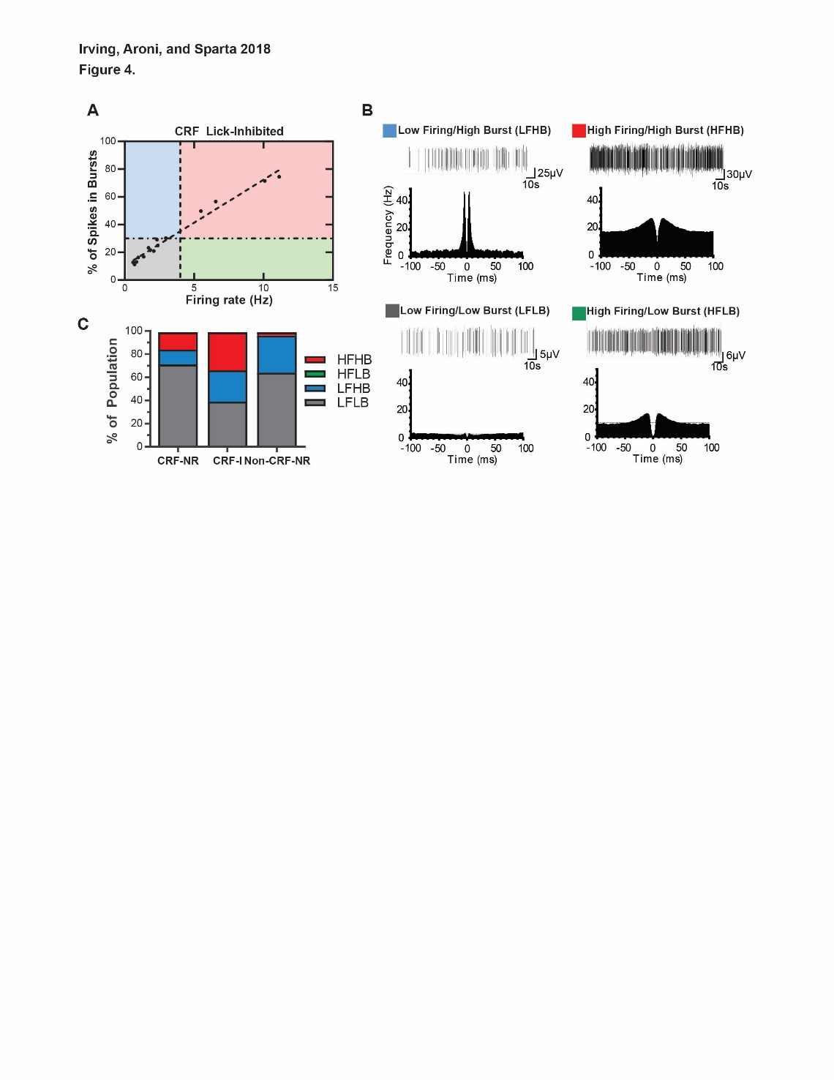

## LEGEND

We further analyzed the firing/burst properties of the units neurons by classifying them into four different groups (using a cutoff of firing rate to 4 Hz, and burst firing to 30%. The four classes were low firing/high burst (LFHB), high firing/high burst (HFHB), low firing/low burst (LFLB), and high firing/low burst (HBLB). **A)** Example spike trains and autocorrelograms from representative units of each class. **B)** Units plotted as % of spikes in bursts vs firing rate. The horizontal dashed line marks the cutoff between low and high bursting (cutoff=30%), and the vertical dashed line marks the cutoff between low and high firing (cutoff=4 Hz). **C)** Population distributions for the burst-firing class for the lick-response types of interest. CRF-P had approximately 26% of LFHB, 23% of HFHB, and 50% of LFLB, whereas CRF-NR showed a low % of LFHB (7%), no HFHB, and a higher % of LFLB (~92%). NonCRF non-lick responsive (NR-NR) units had ~75% LFLB, and 25% LFHB, and a very low % of HFHB units (2%), indicating the HFHB class may be a defining characteristic for CeA-CRF-P units